Aim  
To demonstrate virtualization by installing a Type-2 Hypervisor (VMware Workstation) on the host device, creating and configuring a Virtual Machine (VM) with a host operating system (Windows/Linux).

**Procedure**

1. Download and Install VMware Workstation
   * Visit the official VMware website and download the latest VMware Workstation installer for your host OS (Windows/Linux).
   * Run the installer and follow the prompts to complete the installation.
2. Launch VMware Workstation
   * Open VMware Workstation after installation is complete.
3. Create a New Virtual Machine
   * Click Create a New Virtual Machine from the Home screen or via the File menu.
   * Choose Typical (recommended) setup and click Next.
4. Select Installation Media
   * Choose to install the operating system now using an ISO image file or installation disk.
   * Browse to the downloaded ISO file of the desired guest OS (Windows or Linux).
   * Click Next.
5. Name the Virtual Machine
   * Enter a name for the VM and choose the destination folder to store VM files.
   * Click Next.
6. Specify Disk Capacity
   * Set the virtual disk size (e.g., 15 GB or as per requirement).
   * Choose to store the virtual disk as a single file or split into multiple files.
   * Click Next.
7. Customize Hardware (Optional)
   * Modify RAM allocation (e.g., 2 GB or more) and CPU settings (e.g., 1 or more cores) as required.
   * Adjust other settings such as network adapter, USB controller if necessary.
   * Click Close to save hardware settings.
8. Finish Virtual Machine Creation
   * Ensure the option Power on this virtual machine after creation is checked.
   * Click Finish to create the VM.
9. Install the Guest Operating System
   * The VM will boot from the attached ISO image.
   * Follow the guest OS installation steps inside the VM window as you would on a physical machine.
10. Install VMware Tools
    * After OS installation, from the VM menu, select VM → Install VMware Tools to enhance performance and enable features like drag-and-drop and shared clipboard.
    * Complete the VMware Tools installation inside the guest OS and reboot if required.

**Output:**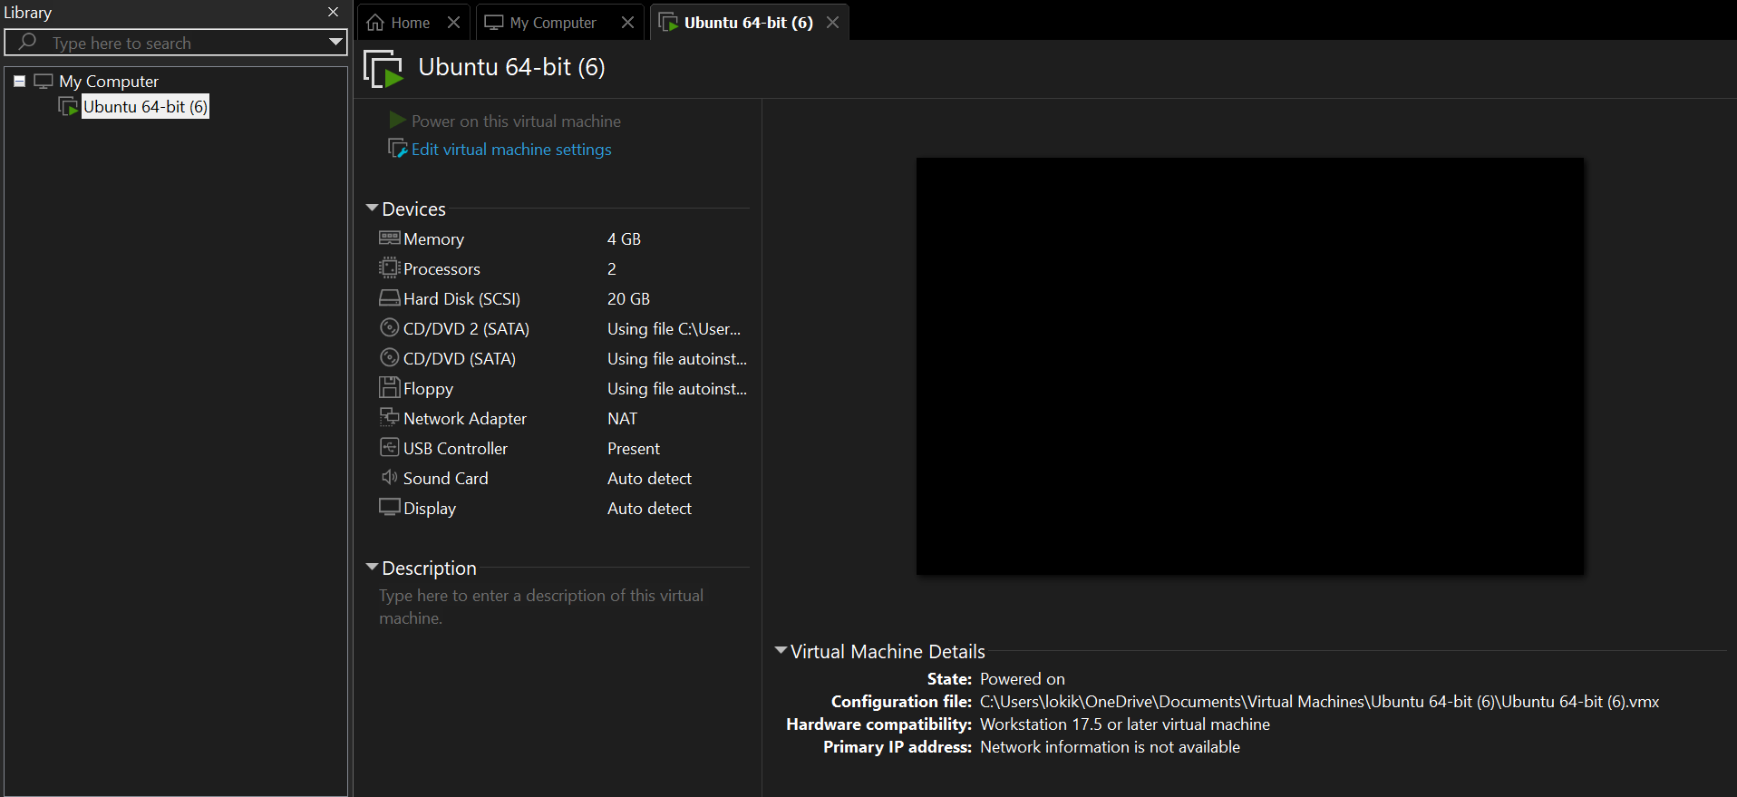

**Result**

A Type-2 Hypervisor (VMware Workstation) was successfully installed on the host system. A Virtual Machine was created and configured with a chosen host operating system (Windows/Linux). The guest OS installed smoothly inside the VM, demonstrating effective virtualization. VMware Tools installation improved VM usability and performance, validating the virtualization environment setup.